
The following is a brief report on the trip of Carlos and Lucena to Colombia from the 15th of January to the 16th of February of this year. Also included is an update on Carlos’ theological studies.
By the grace of our Lord and the support of a number of generous individuals and churches, to whom we are very grateful, we (Carlos & Lucena) we were able to spend 30 days to our home country to visit our parents. They have been very sick but we have hope in God’s will for them and are thankful for your prayers.
VISIT WITH LUCENA’S FAMILY IN THE CITY OF BOGOTÁ  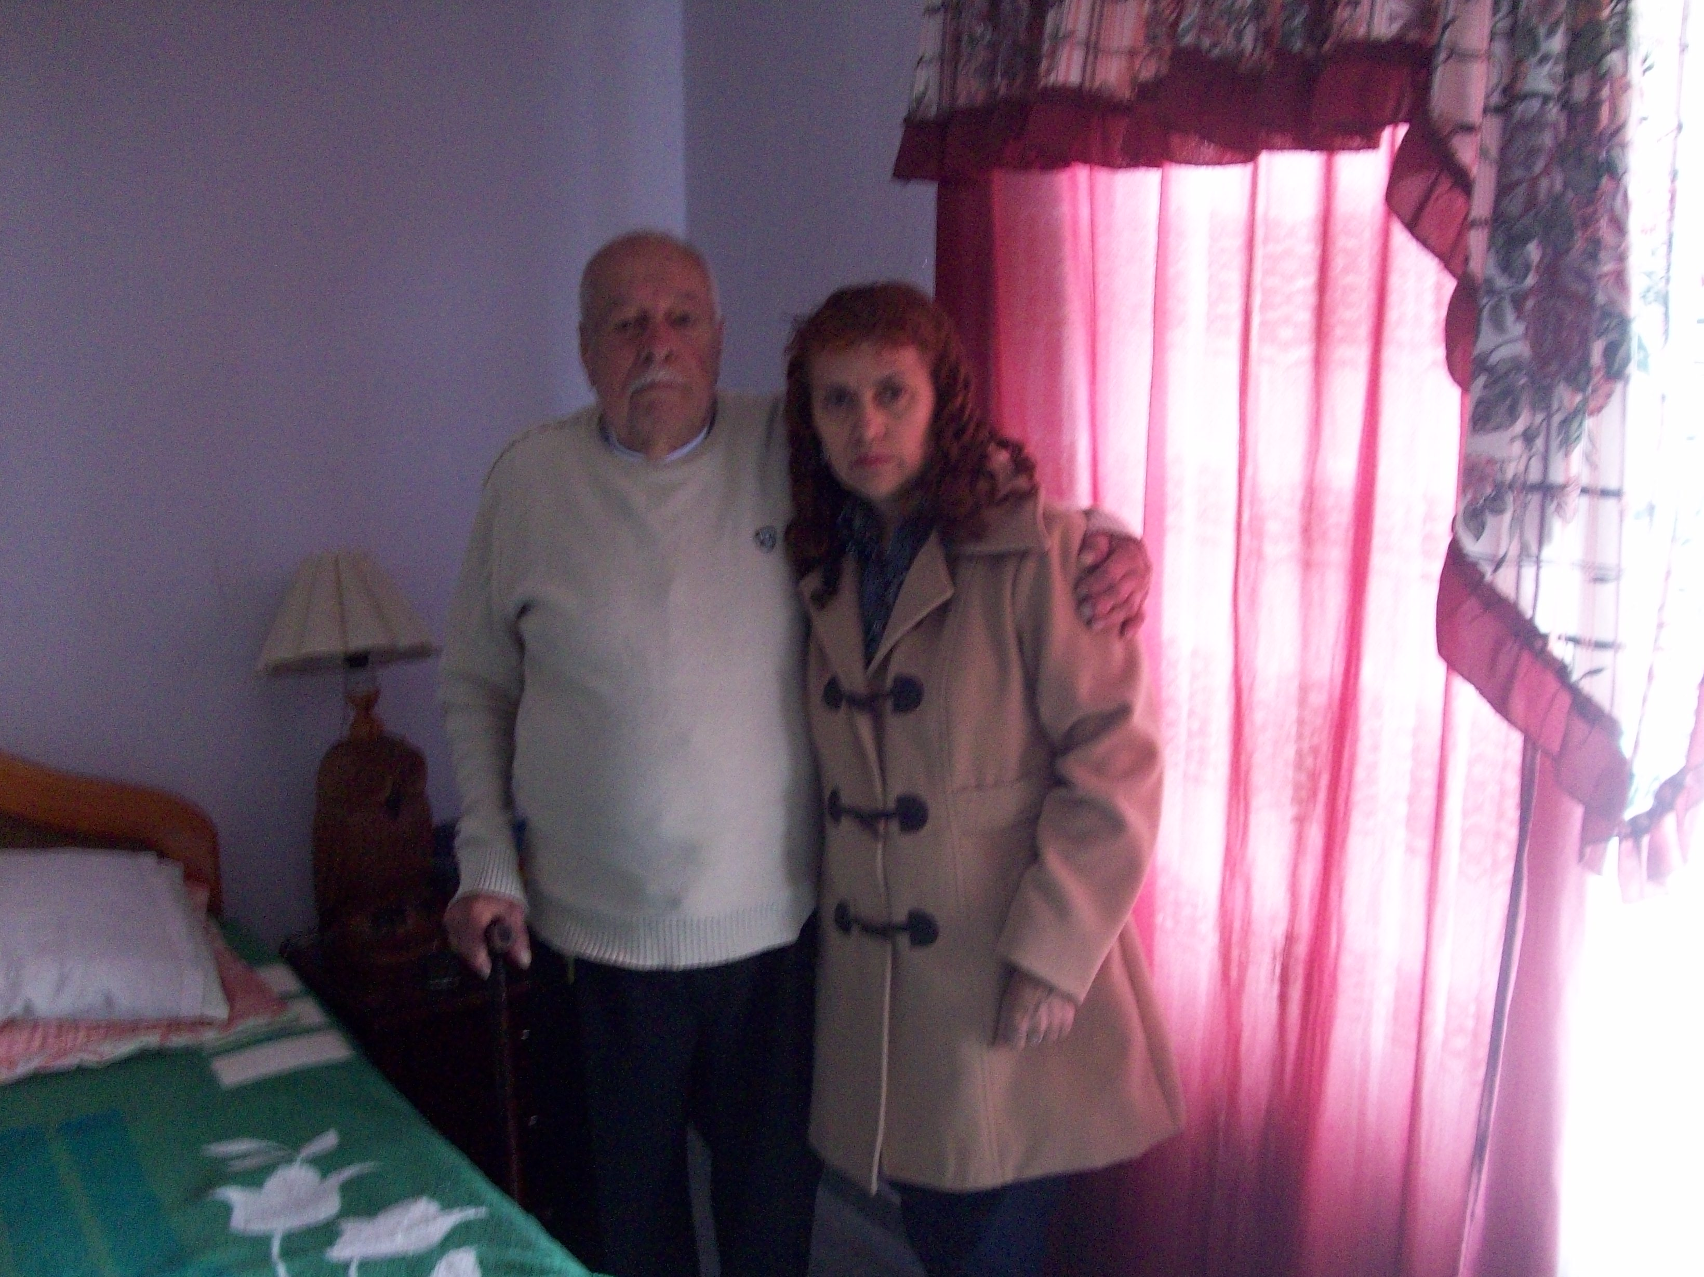 | In this picture is Lucena Ardil with her father, brother Ruben Gutiérrez who is 86 years of age and who had to be hospitalized again. He is now in critical condition in the intensive care unit.
VISIT WITH THE FAMILY OF CARLOS IN THE CITY OF MEDELLÍN
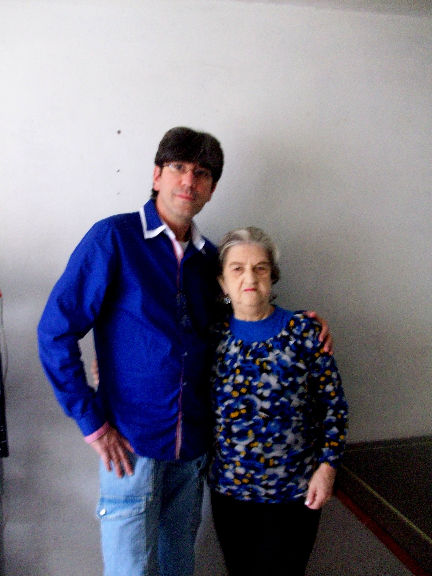

In this picture Carlos Ardila is standing with his mother, sister Rosa Yepes who is 76 years of age. She is presently suffering with osteoporosis and other physical issues due to curvature of the spine.

PREACHING THE WORD OF GOD IN BOGOTÁ  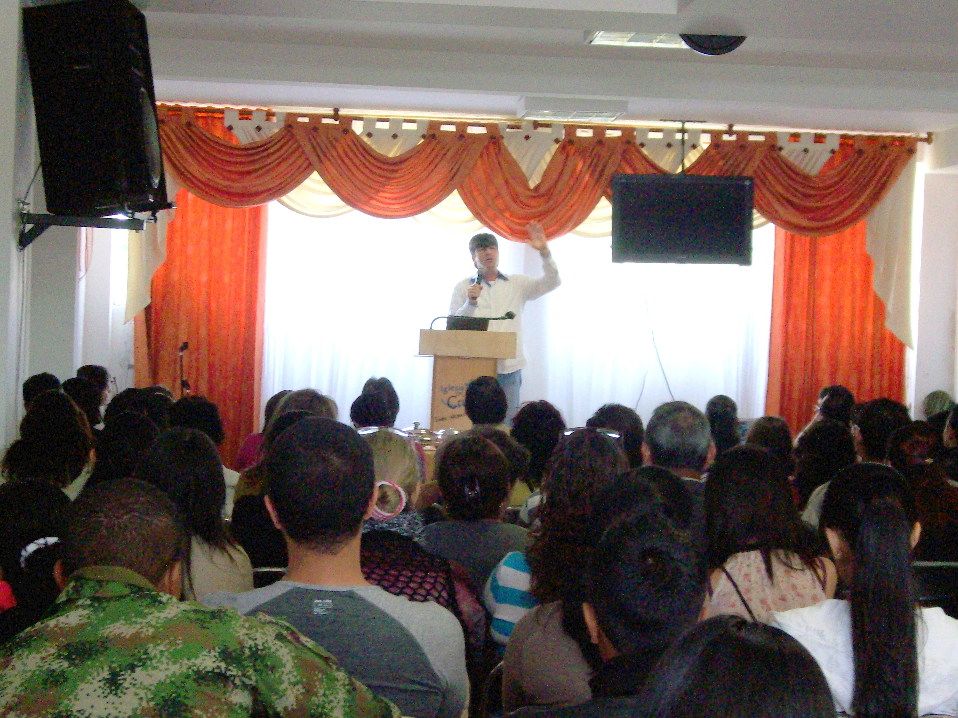 | PREDICACIÓN DE LA PALABRA DE DIOS EN LA CIUDAD DE MEDELLÍN  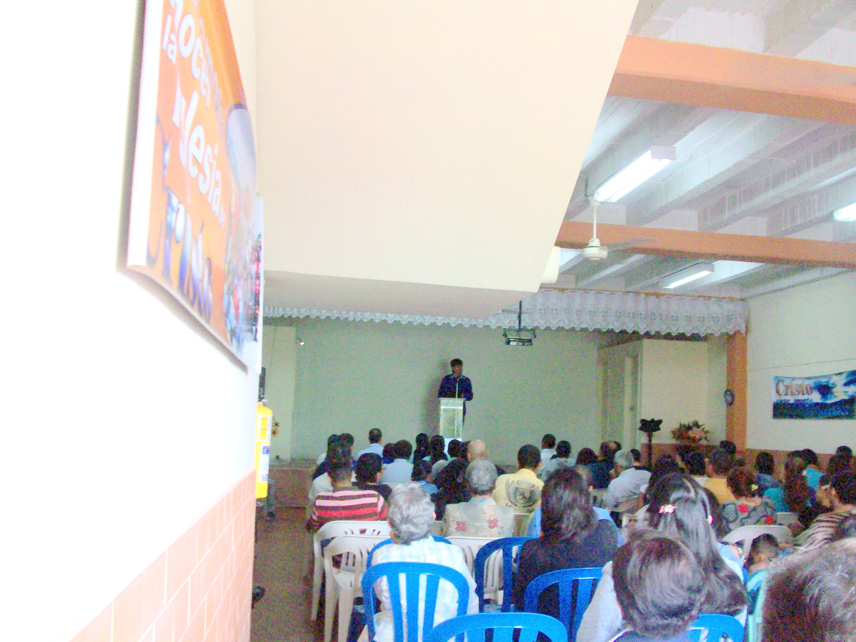
Carlos Ardila preaches this past 16th of February in the Salitre congregation in the city of Bogotá. | In the photo above, Carlos Ardila preaches on the 2nd of February in the Barranquilla congregation in the city of Medellín.

GETTING BACK TO OUR ACTIVITIES IN THE CHURCH OF CHRIST IN VILLA URQUIZA
AS WELL AS THE THEOLOGY STUDIES
GETTING ACTIVITIES STARTED AGAIN

Thanks to our Father God, from this past 17th of February, we have the great privilege of continuing our service in Argentina and we have started anew our activity in the congregation.

THEOLOGICAL STUDIES

Staring this past 20th of February, Carlos has been taking his last set of final exams for his accreditation as a Theological Counselor at the Seminario Internacional Teológico Bautista of Buenos Aires and with God’s help on March 28th he will take the last exams to be able to finish up that degree.

WEBSITES:
http://iglesiadecristourquiza.blogspot.com.ar/
https://www.facebook.com/AudiosCristianosCortos?ref=hl
http://encomunionconvos.blogspot.com.ar/

