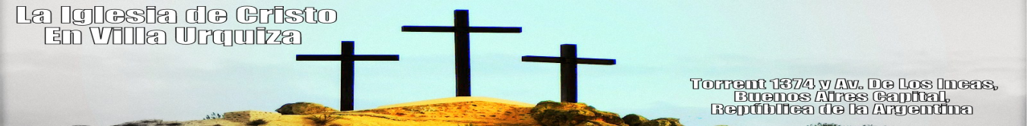
This is a two-month report for the Villa Urquiza congregacion for the months of March & April of 2015:

FINISHING UP THE REMODELING OF OUR BUILDING

In this picture is a partial few of the some of the meeting rooms in our building that have been remodeled. The work of the repairs was finished on Friday, the 30th of January and the entire space we use were improved for use for the church’s activities.

YOUTH CAMP IN MÁXIMO PAZ

In the left picture Carlos Ardila is teaching the youth that were in attendance in the camp that was organized by the Caballito church. The camp was the 2nd to the 8th of February and 13 members of the Villa Urquiza church were in attendance. As one of the teachers invited to the camp, Carlos Ardila spoke during three sessions that were taken from the Gospel of John.

LADIES’ MEETING IN VILLA URQUIZA

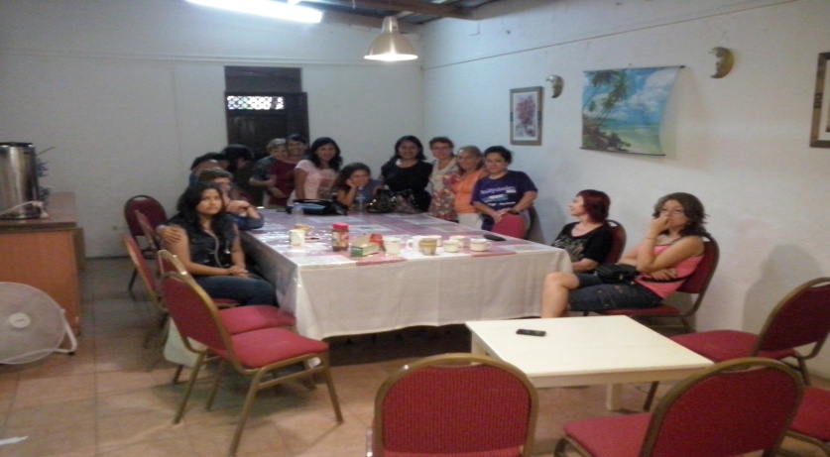

In this picture, between 15 and 20 ladies in attendance in our building at the ladies meeting on February 14th. During this meeting, after singing together, the ladies were given a lesson on edification by sister Lucena Castillo (sixth from the left in this picture) and after the lesson they shared lunch together.

On Social Media
http://www.facebook.com/AudiosCristianosCortos
Brief Christian Recordings
Messages to share and to evangelize by Carlos Ardila and broadcast on the internet and by flyers passed out in the streets.

WEEKLY MEETINGS:
Sunday: Worship at 10:30 a.m.
Every Other Wednesday : Pueyrredon 1925, 2nd Floor, at 8:00 with Carlos Ardila.
Every Other Wednesday: Lavalle 2978, 2nd Floor, Apt. 7, 8:00 p.m. with Carlos Ardila.
Note: For the next while the Wednesday Bible studies will rotate. In other words the studies will be every other Wednesday at each address.
Friday: At 8:00 p.m. in our bulding with Carlos Ardila.
Saturday:
1. Paraná 235, Lomas de Zamora, at 6:00 p.m. with Juan Fuente.
2. Every other Saturday the young people meet in our building and are lead by Erick Otiniano.

